A COMMUNITY SERVICE PROJECT REPORT ON

HEALTH AND HYGIENE

Submitted in partial fulfillment for the award of the degree of

BACHELOR OF TECHNOLOGY

IN

Computer Science and Engineering

By

# MATTA PRATHYUSHA DHANA LAKSHMI

22A81A05G3

Under the Esteemed Supervision of

Mrs. D.S.L MANIKANTESWARI Assistant Professor



Department of computer science and Engineering (Accredite by N.B.A)

SRI VASAVI ENGINEERING COLLEGE(Autonomous)

(Affiliated to JNTUK, Kakinada)Pedatadepalli,

Tadepalligudem-534101, AP 2022-23

SRI VASAVI ENGINEERING COLLEGE

(Autonomous)

Department of Computer Science and Engineering

Pedatadepalli, Tadepalligudem





This is to certify that the Community Service Project Report entitled “HEALTH AND HYGIENE” survey done in Peravali village, submitted by Matta Prathysha Dhana Lakshmi (22A81A05G3), for the award of the degree of Bachelor of Technology in the Department of Computer Science and

Engineering during the academic year 2022-2023.

|  |  |
| --- | --- |
| Name of Project Guide | Head of the Department |
| Mrs.D.S.L Manikanteswariz | Dr. D Jaya Kumari |
| Assistant professor | Professor&HOD |

ACKNOWLEDGEMENT

First and foremost, we sincerely salute to our esteemed institute SRI VASAVI ENGINEERING COLLEGE, for giving us this golden opportunity to fulfill our warm dream to become an engineer. Our sincere gratitude to our project guide Mrs.M.S.Radha Mangamani Assistant Professor, Department of Computer Science and Engineering, for his timely cooperation and valuable suggestions while carrying out this project.

We express our sincere thanks and heart full gratitude to Dr. D. Jaya Kumari, M.Tech, Ph.d, Professor & Head of the Department of Computer Science and Engineering, for permitting us to do our project. We express our sincere thanks and heart full gratitude to Dr. G.V.N.S.R. Ratnakara Rao, Principal, for providing a favorable environment and supporting us during the development of this project.

Our special thanks to the management and all the teaching and non-teaching staff members, Department of Computer Science and Engineering, for their support and cooperation in various ways during our project work. It is our pleasure to acknowledge the help of all those respected individuals.

We would like to express our gratitude to our parents, friends who helped to complete this project.

## M.P.Dhana.Lakshmi.

(22A81A05G3)

SRI VASAVI ENGINEERING COLLEGE

(Autonomous)

Department of Computer Science and Engineering

Pedatadepalli, Tadepalligudem

(2022-2023)

Community Service Project for the UG Program

HEALTH AND HYGIENE

Name of the Student : Matta Prathyusha Dhana Lakshmi

Regd No : 22A81A05G3

Branch : CSE

Semester : III

Topic : HELATH AND HYGIENE

Area : Peravali

Project Guide : Mrs.D.S.L Manikanteswari

Asst.Professor

(Project Guide)

(Student) Mrs.D.S.L Manikanteswari

Asst.Professor

**CONTENTS:**

* Introduction
* Awareness on hygiene
* Awareness forms on awareness program
* Photographs of Surveys
* Suggestions
* Conclusion

# **INTRODUCTION**

Health is defined as a state of complete physical, mental and socialbeing and not merely an absence of disease or infirmity. physical health and mental health are inter-related. a sound mind in a sound body is an old and appropriate saying for good health. hygiene is a set of practices performed to preserve health.

Having proper healthcare facilities is a fundamental right of every human being, and it is an integral part of human development. Providing primary health facilities is essential to improve the health conditions of individuals in India.

Good health will not only improve living conditions, but it will also help to bridge the gap between the rural and the upper class. The health of the individual depends mainly on the fulfilment of the basic needs of the body.

Clean water and a clean habitat are the two basic requirements of an individual to live life in a healthy manner. If clothes are washed, or the body is washed with dirty water, it will lead to the rise of diseases.

**RURAL SITUATION:**

Rural Sanitation in India is a subject of utmost concern and among the top agendas of GOI (Government of India), which is the basis for the development of the nation. Various aspects of development are interlinked with sanitation which includes-

* In the scenario of inadequate sanitization, the health conditions degrade miserably, which adversely affects the economy of the country.
* Without proper sanitization, the tourism industry will fail miserably, contributing a significant fraction of the nation’s GDP. Hygiene can be divided into two parts- **Personal Hygiene:**

The level of personal hygiene is abysmal in rural Indian and hence, is the root cause of various health problems. People generally bath and wash clothes in rivers and pollute their primary source of water. They do not wear clean clothes, nor do they pay any attention to washing their hands, or taking care of their nails, feet, teeth, and hair. Coughing, and sneezing directly on people’s faces and nose is a common practice there. All these habits of people in a rural area become the root cause of many health hazards.

**Environmental Hygiene:**

Environmental hygiene includes domestic and community-driven efforts. They lack knowledge about the benefits of living in the fresh air, good light, proper ventilation, hygienic cooking and storage of food, and sanitary disposal of waste material.

**Ways to Improve Rural Hygiene**

* Personal hygiene depends on the adequate availability of water for drinking and sanitation. Providing sufficient water could be helpful in improving rural hygiene.

* Awareness programs should be organized to provide information about the importance of hygiene.

* More schemes like Swachh Bharat Abhiyan and Nirmal Bharat Abhiyan should be introduced for a better and cleaner tomorrow. causes a lot of diseases.

**What to Expect With Good Hygiene:**

Practicing good hygiene requires you to perform a series of basic personal hygiene habits on a regular basis. Wash your body and hair often to remove bacteria and dead skin cells. Brush your teeth after every meal, or at least twice per day. Flossing and brushing regularly help prevent the accumulation of bacteria in the mouth that increases the risk for gum disease.

Wash your hands every time before eating or preparing food and after coming into contact with bacteria and viruses — in restrooms and after coughing or sneezing and taking out the garbage. Trim your fingernails and toenails regularly, and take steps to ensure your feet are clean and dry at all times.

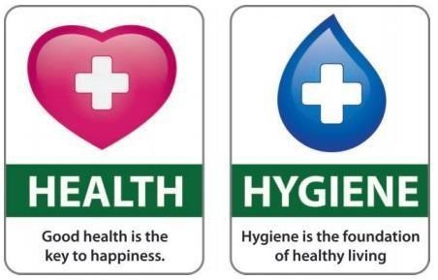

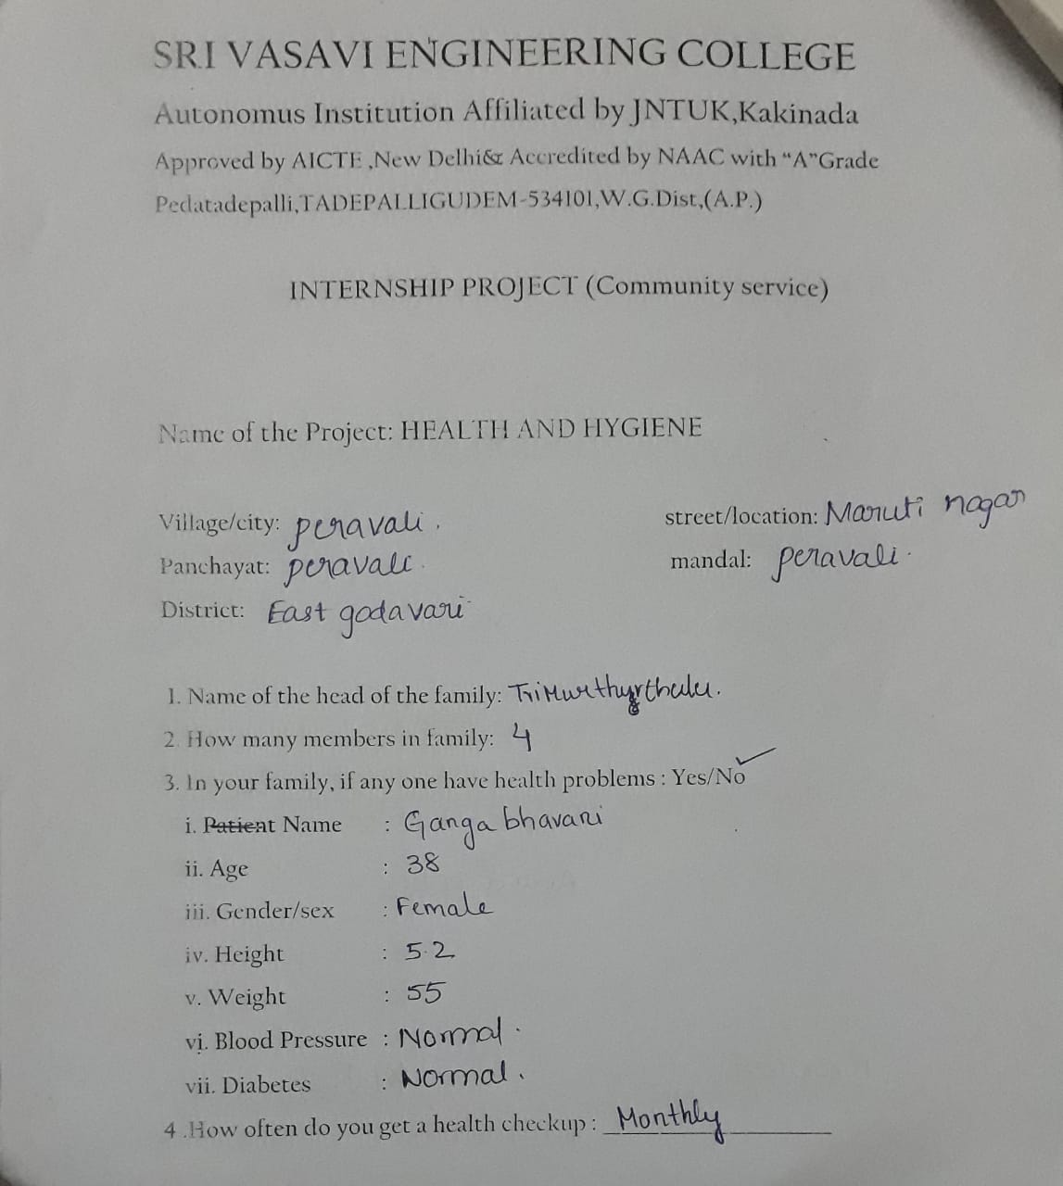

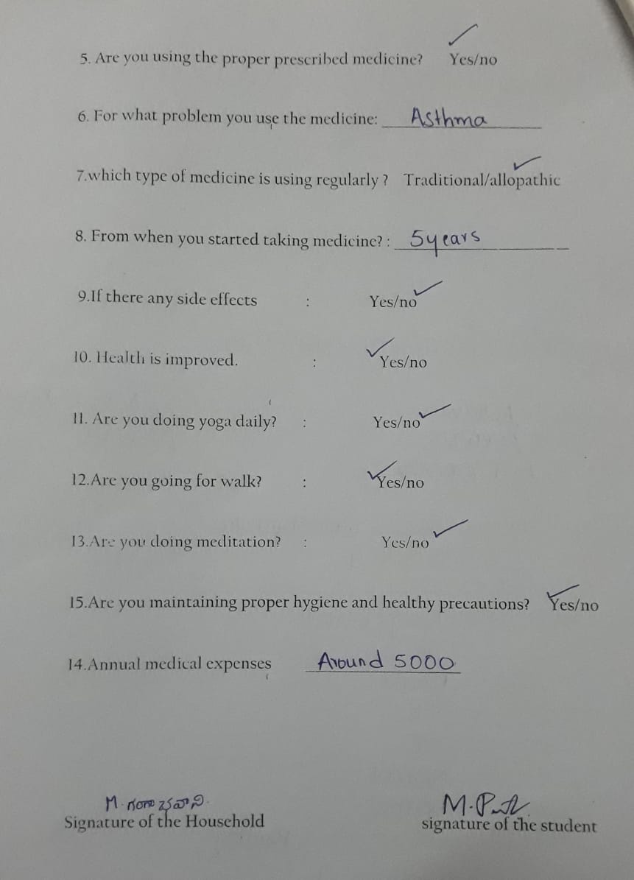

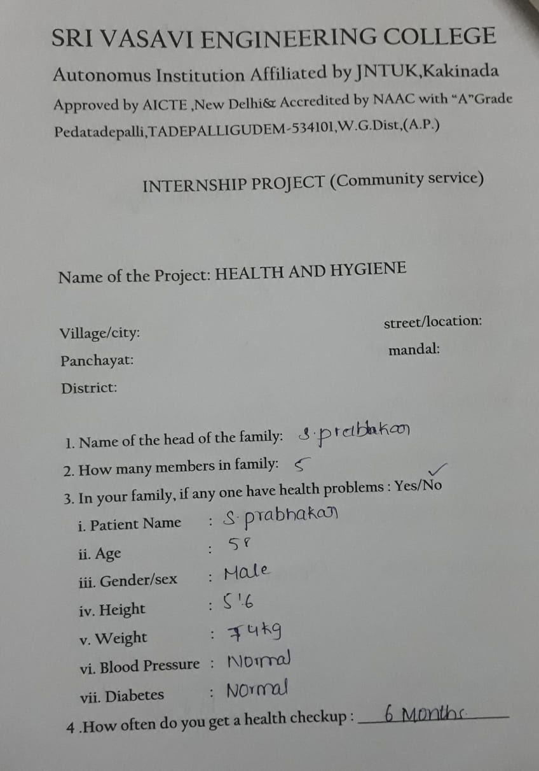

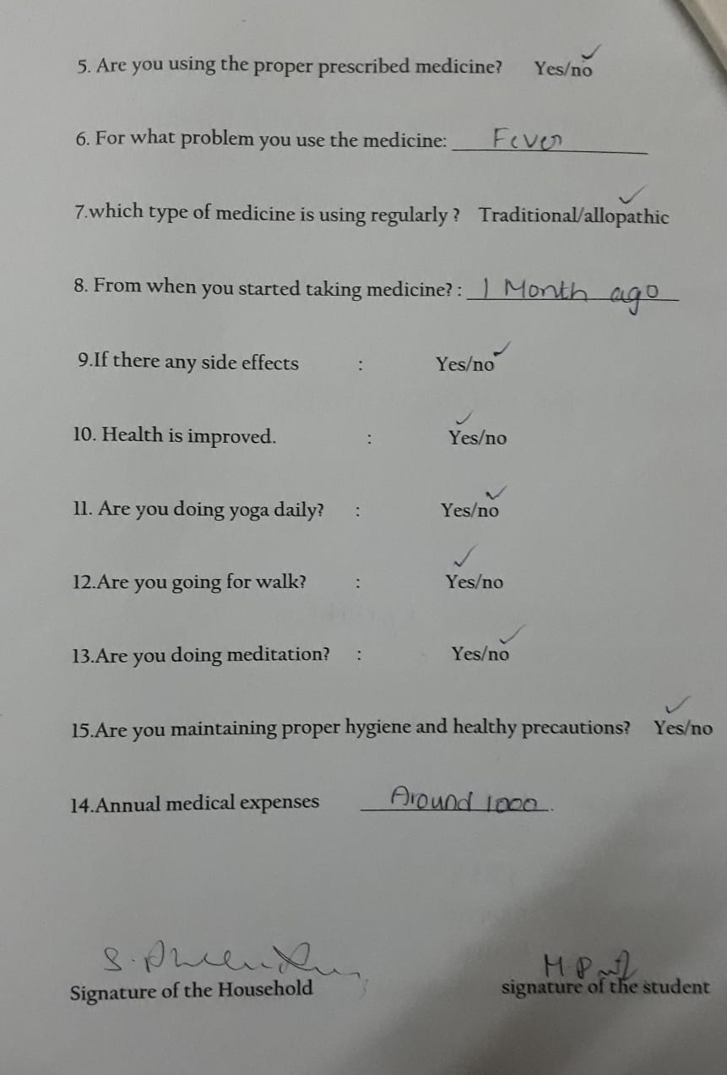

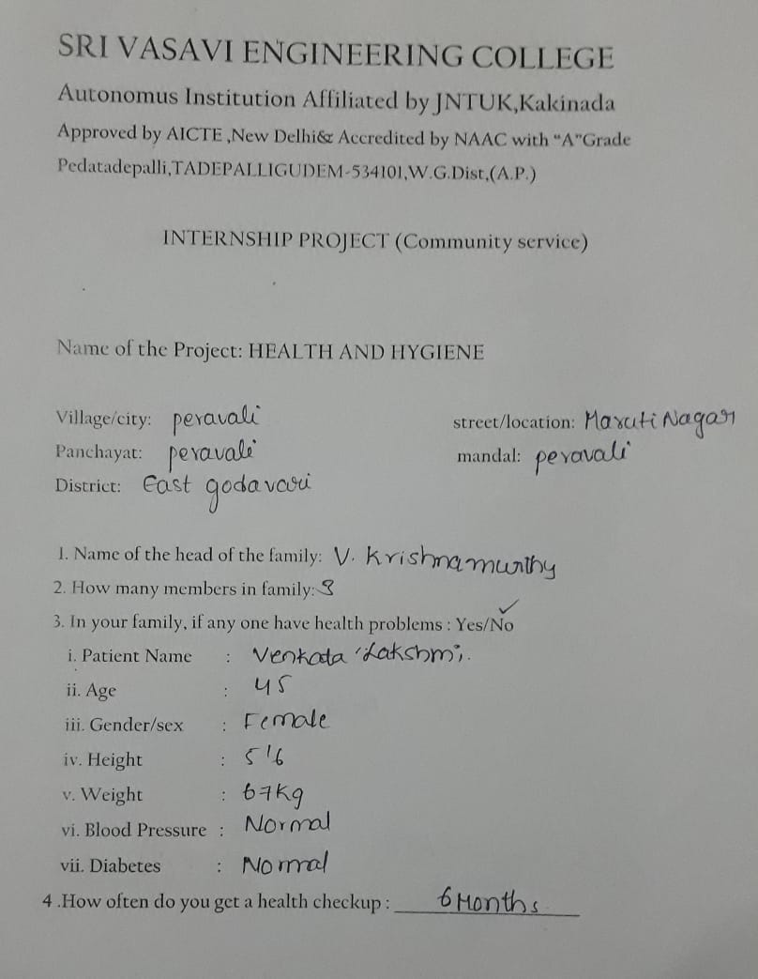

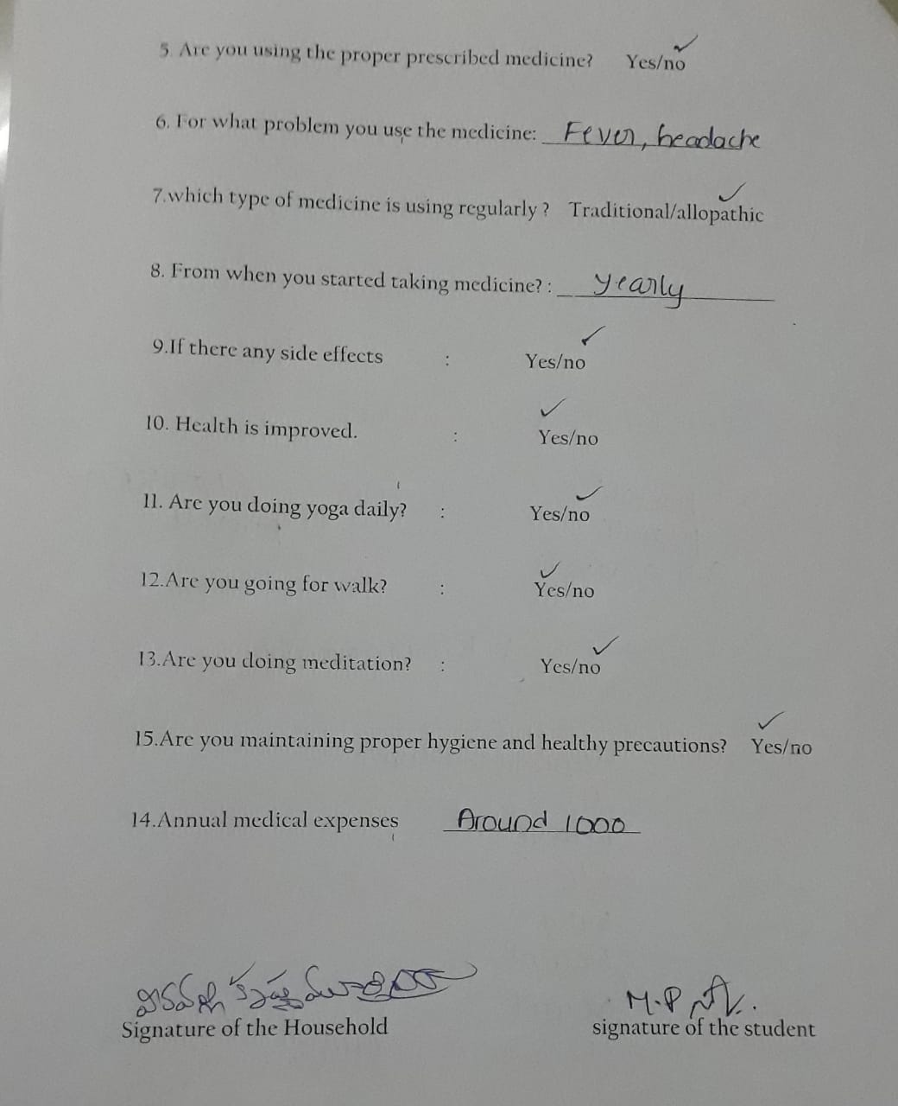

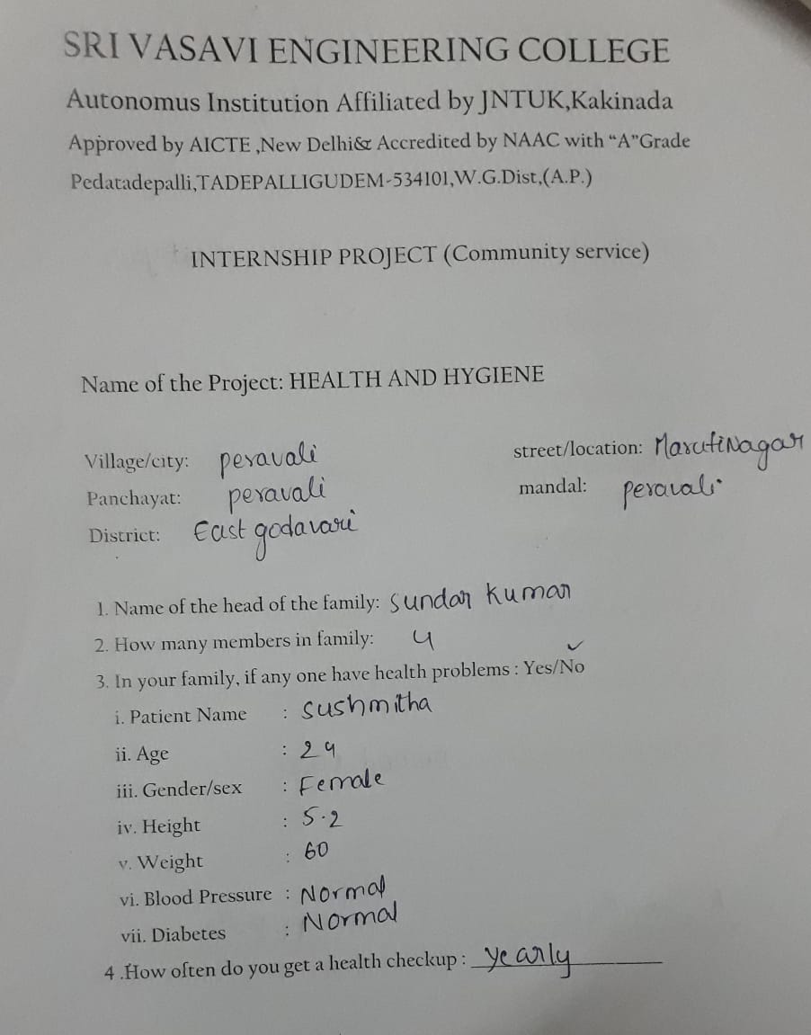

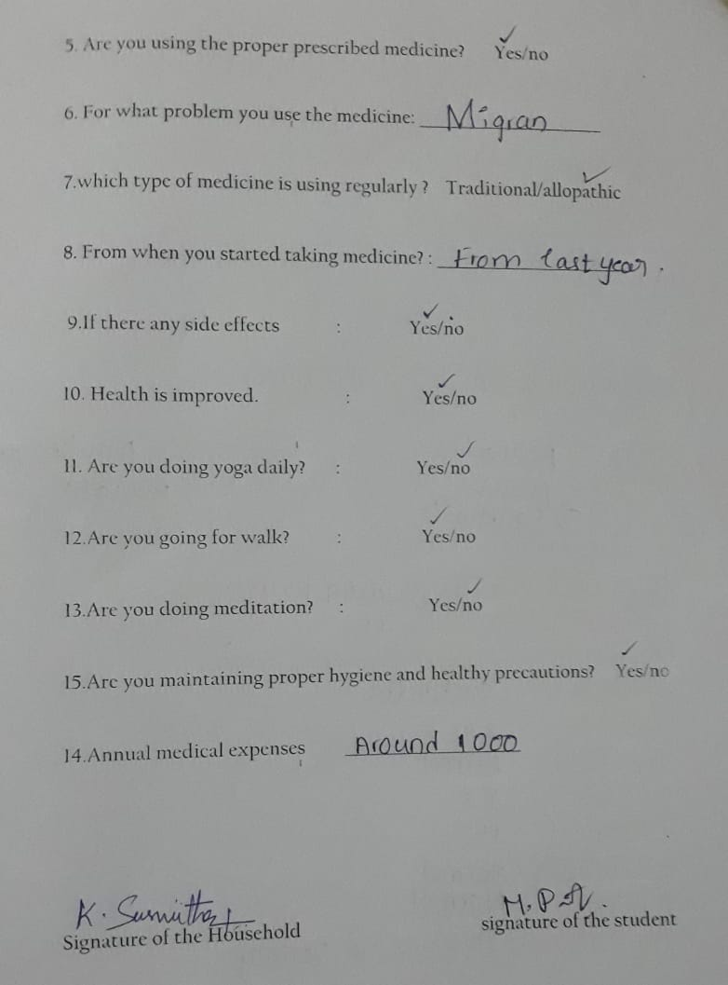

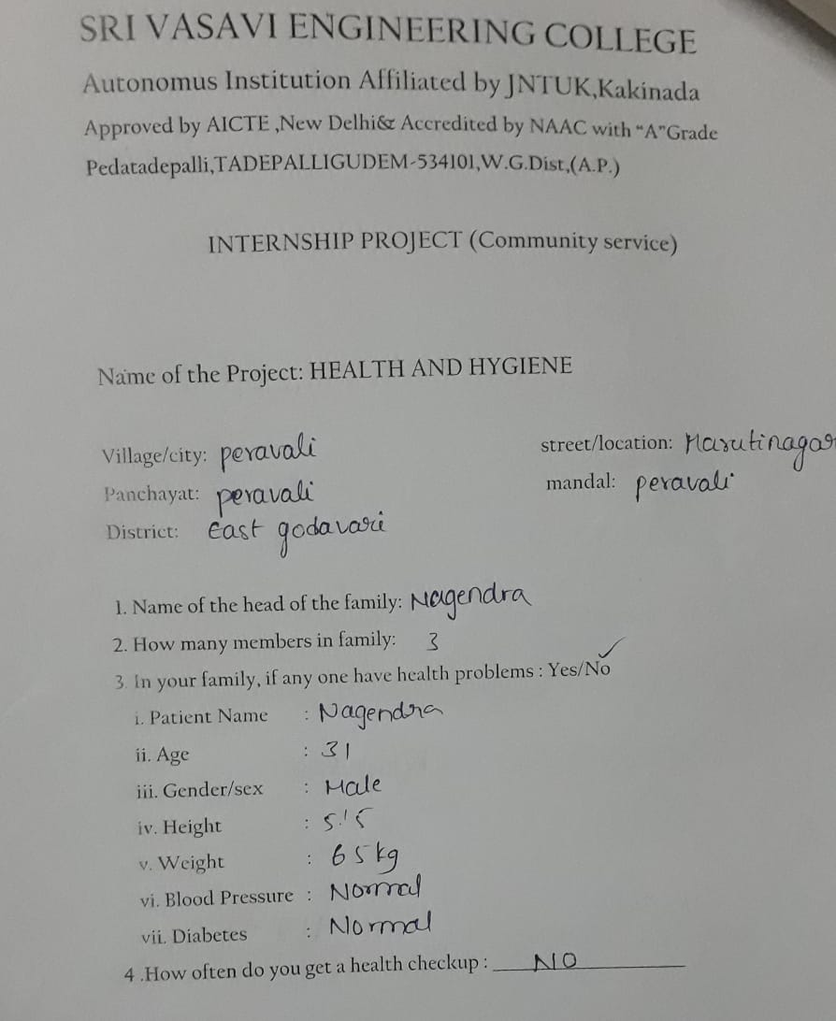

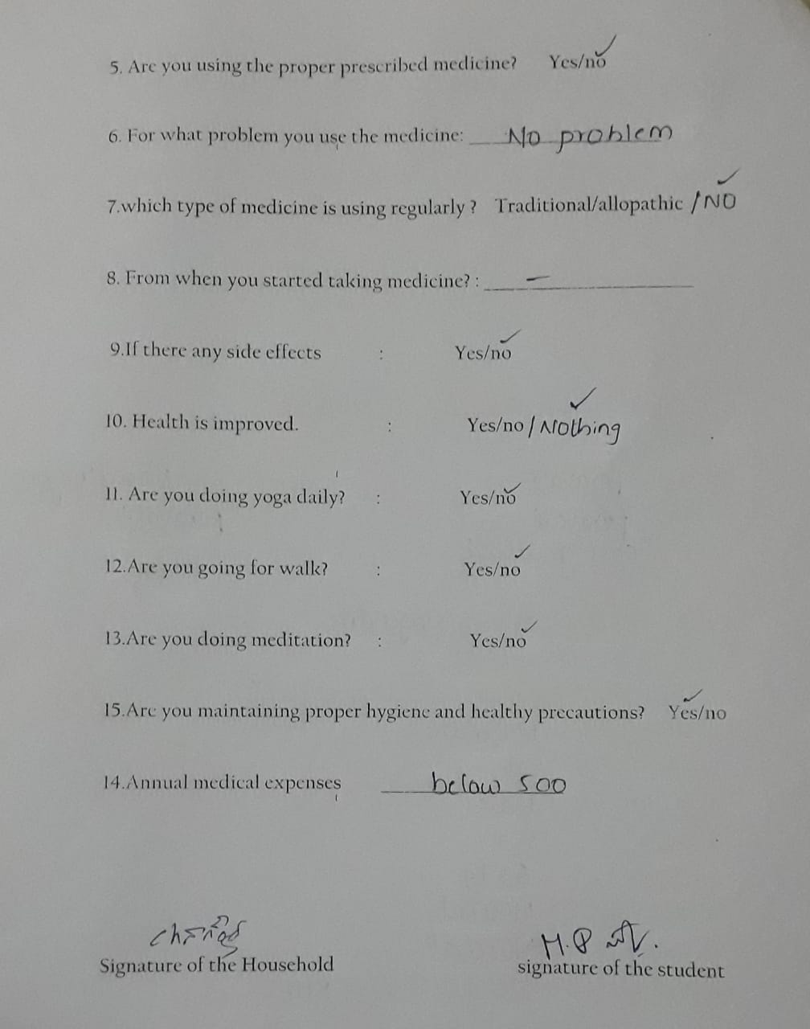

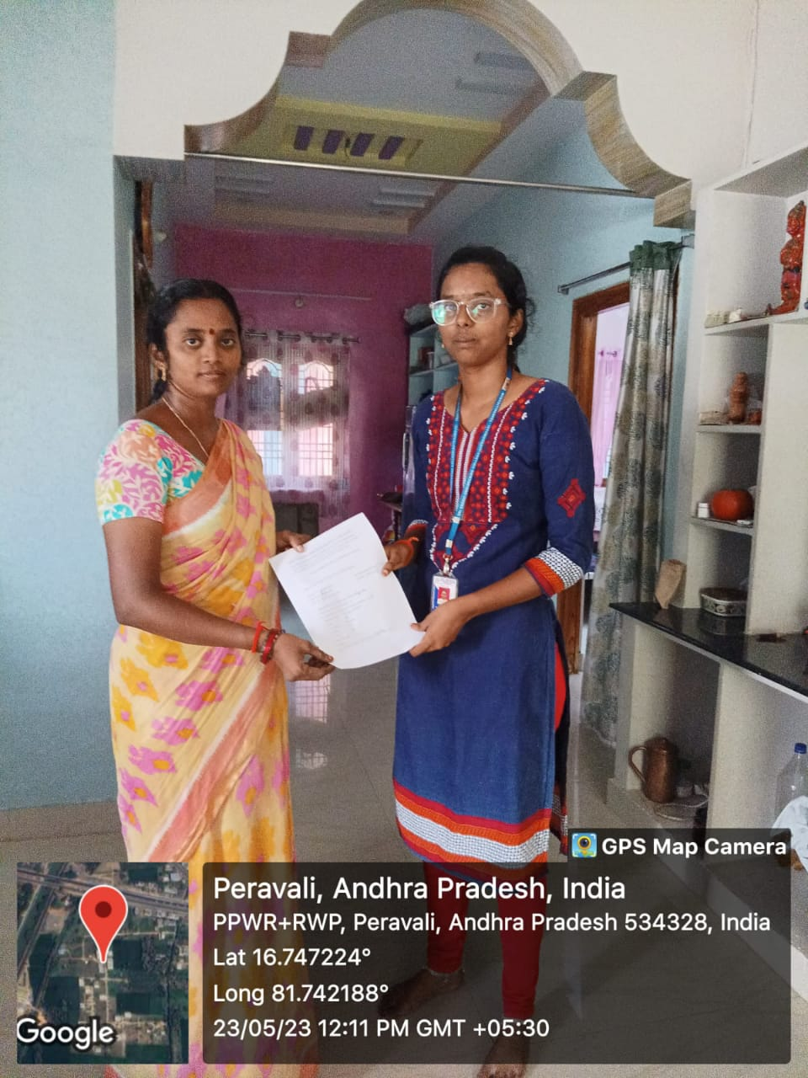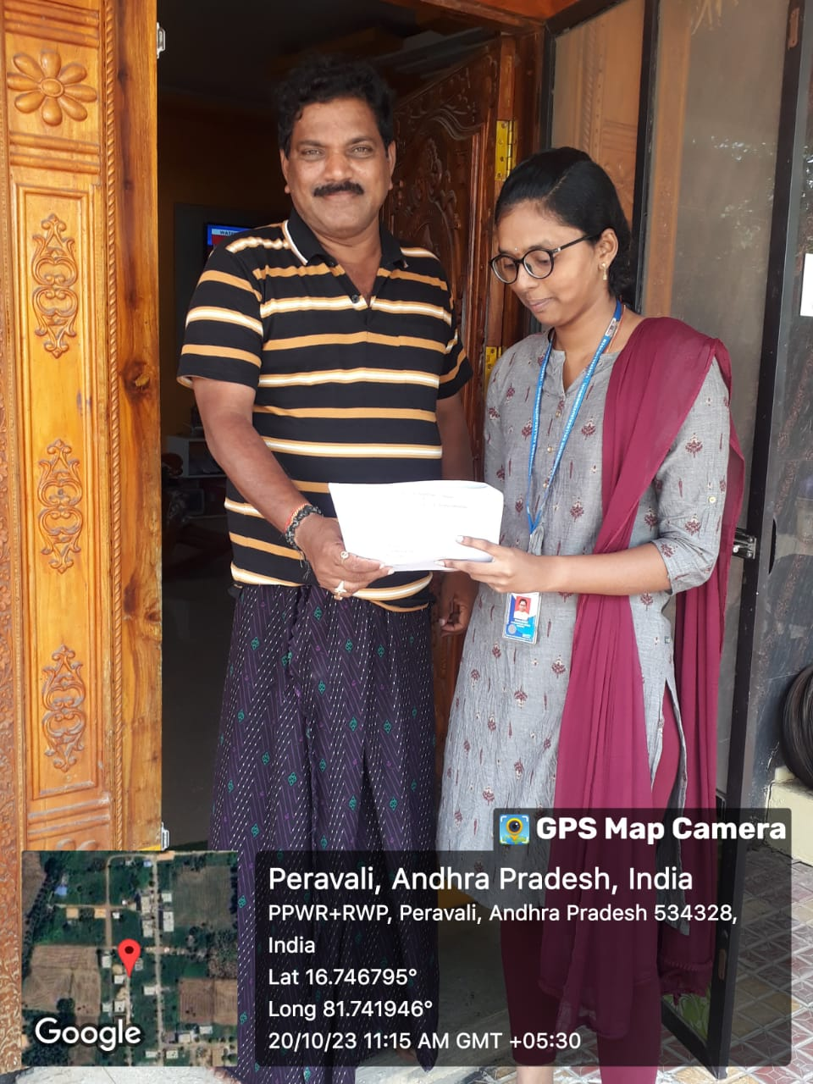 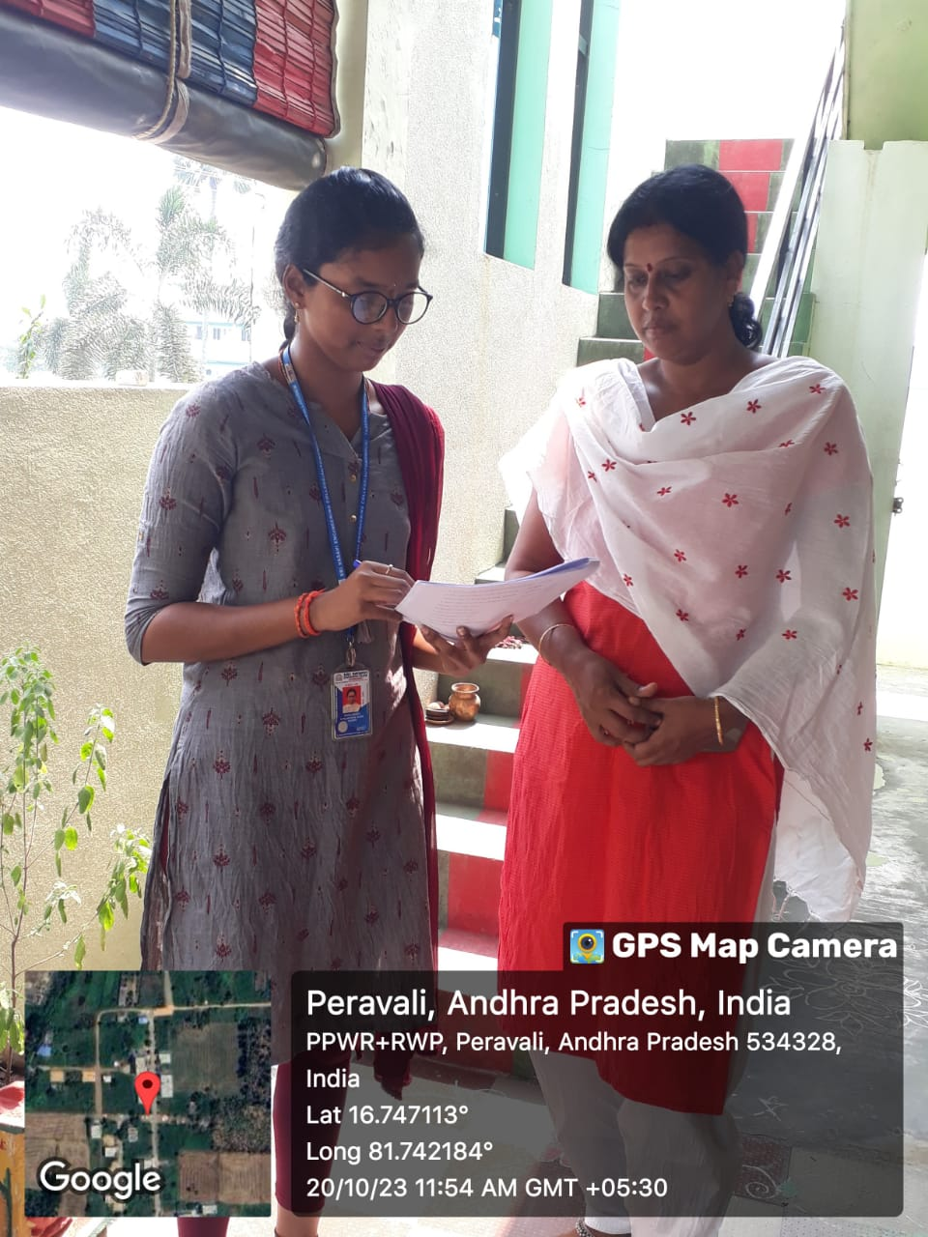

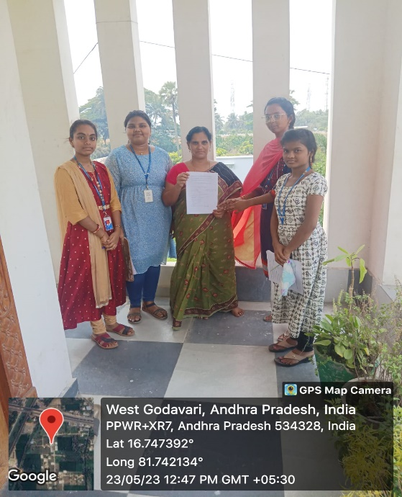

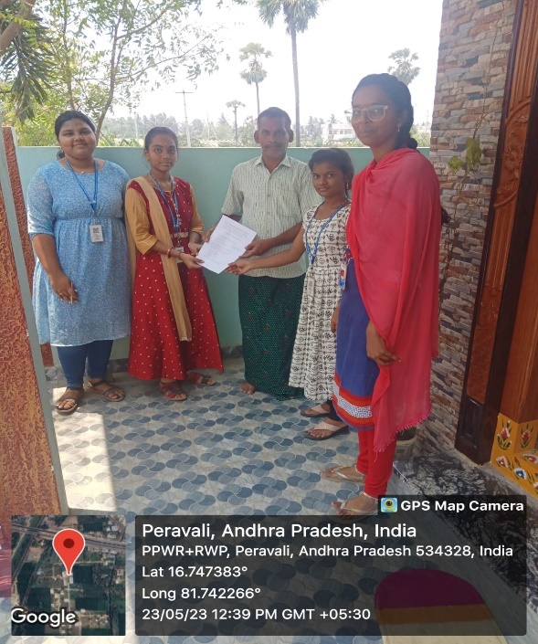

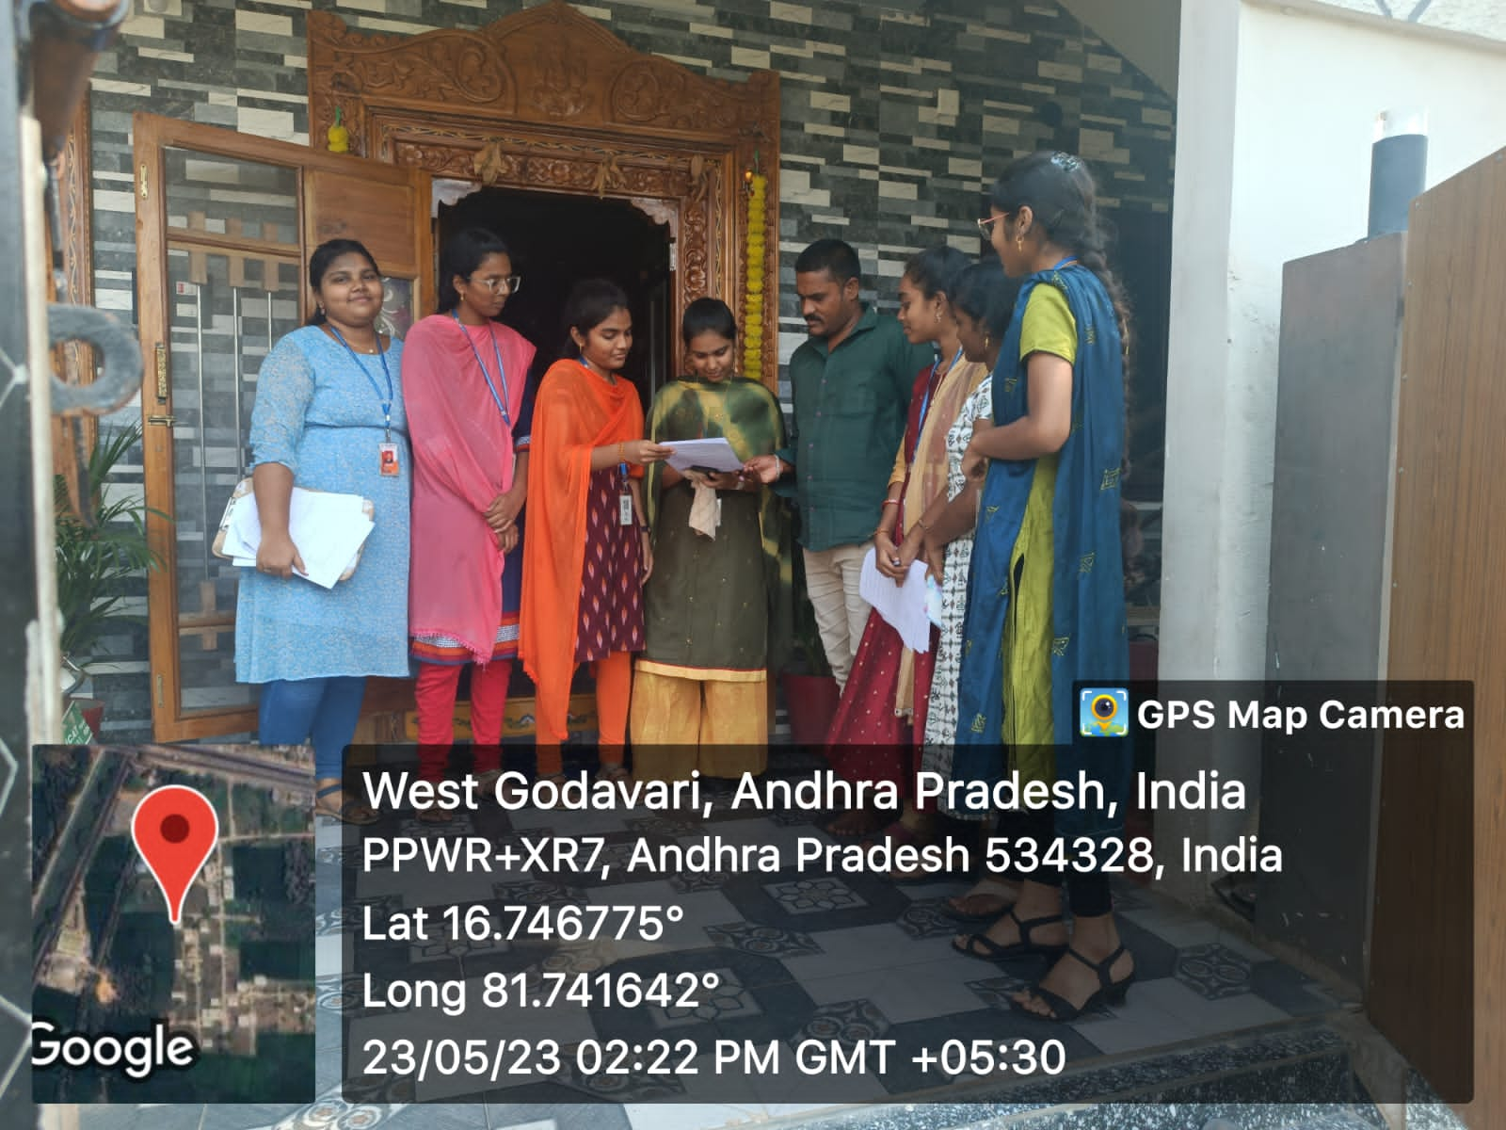

## SUGGESTIONS

Here are some safety tips to keep your surroundings clean:

* Clean your home with effective cleanings agents.
* Use two different trash bins to throw dry waste and wet waste separately.
* Make sure that municipal workers take off the home waste once in a week.
* Ask municipal workers to clean drainages regularly.

Here are certain tips to stay hygiene:

* Wash your hands with soap and water.
* Use a tissue when you cough and sneeze.
* Clean the surfaces in your home regularly.
* Brush at least twice a day,in the morning and at night.
* Use a hand sanitizer.
* Clean your water storing vessels daily.

# **CONCLUSION**

The health and hygiene are the two factors that play an important role in human’s life.The lifespan of human beings is mostly based on the individual’s health.

The health is maintained by taking hygiene food at proper interval of time.The morality rate can be decreased if the person consume only hygienic food and maintain his health in good condition.This is because,most of the food items acts as medicines for certain diseases.Thus,being healthy and consuming hygienic food is essential.

Good personal hygiene is one of the best ways to protect oneself from getting illness.Maintaining good personal hygiene will also help prevent you from spreading diseases to other people. good hygiene lowers a person’s risk for diseases and illnesses commonly spread through viruses and bacteria.

## **“AROGYAME MAHA BHAGYAM”**

|  |  |
| --- | --- |
| Student name | Matta Prathyusha Dhana Lakshmi |
| Regd.no | 22A81A05G3 |
| Branch | CSE |
| Year | 2022-2023 |
| Title | HEALTH AND HYGIENE |
| Guide name | Mrs.D.S.L.MANIKANTESWARI |

|  |  |  |  |  |  |
| --- | --- | --- | --- | --- | --- |
| S.no | DATE | Guidance Given | Student activities | Target Achieved | Signature of Guide |
|  |  |  |  |  |  |
|  |  |  |  |  |  |
|  |  |  |  |  |  |
|  |  |  |  |  |  |
|  |  |  |  |  |  |
|  |  |  |  |  |  |
|  |  |  |  |  |  |

Project Guide Project Coordinator Head of the Department